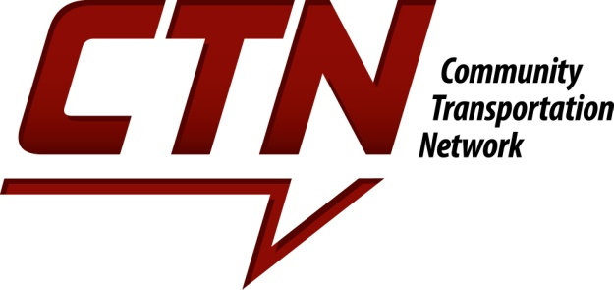
For Immediate Release
Contact: Justin Clupper, Executive Director, CTN
Phone: (260) 420-3407
justin@ridectn.org

COMMUNITY TRANSPORTATION NETWORK ANNOUNCES CHANGES TO SUPPORT COMMUNITY’S NEEDS
Shifts full focus to supporting necessity transportation

Fort Wayne, In, March 17, 2020 -- In the midst of the Covid-19 pandemic and in an effort to support the community’s needs as best as possible, Community Transportation Network (CTN) is shifting all transportation efforts to support those with a medical necessity to access healthcare for the next 60 days. CTN is working with state and local partners to coordinate transportation, especially for low-income seniors and people with disabilities. Individuals having symptoms of Covid-19 are asked to speak with their medical provider’s office before confirming a trip with CTN. Further, CTN has significantly increased its cleaning practices, sanitizing the vehicle after each client departs.

“Our community is hurting and stressed,” says Justin Clupper, CTN executive director. “We recognize that the need to access healthcare resources right now including dialysis and chemo treatments, pain management centers, and other life-sustaining appointments are critical to the continued health of our community.” CTN is mostly expanding its service through Medicaid, but is allowing individuals to pay privately, too.

In addition to shifting this focus, CTN is launching an on-line fundraising effort to offset the costs associated with increased medical transportation. The average medical trip costs CTN over $50, but the average trip fee is closer to $10. This gap is covered by grants and donations from the community and area businesses. “Traditionally, we try to raise funding before we launch a new medical route,” says CTN Board President Michael GeRue. “In this instance, we’re putting service and the needs of our riders first because it is the right thing to do and hoping the donations from the community follow.”

Launched in 2000, CTN has been well known for its door-through-door non-emergency medical transportation program. Most residents, however, are unaware of the additional transportation services provided to the community. This includes low-cost large group transportation for other non-profits, and rides to work for people with disabilities. Effective immediately, CTN is reducing the number of rides provided through those other programs for the next 60 days in order to support the current medical need. Current riders, especially those using CTN to get to work, will still receive that support. No new service will be added during this time.

Individuals interested in riding with CTN should contact the office at 260-420-3280.

About Community Transportation Network: CTN is a private nonprofit organization that provides accommodating transportation for seniors, people with disabilities, low income families, children, youth, and the organizations that serve them. Services have grown to providing over 100,000 trips to more than 8,000 individual riders annually. Trips ensure the rider’s access to programs, healthcare, recreation, and work.

